A young girl called Sophia Wearing a princess gown and a tiaraSmiling gentlyLong wavy brown hairKind and compassionate personalityFantasy illustration style Sophia wakes up in bed as sunlight fills her room. She stretches and gets ready to start her day.

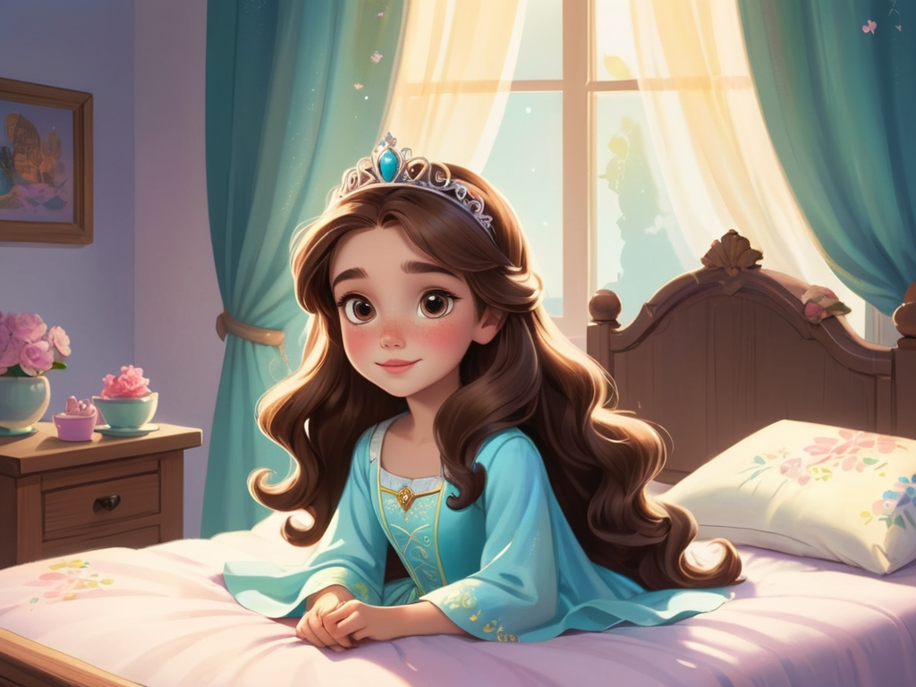

A young girl called Sophia Wearing a princess gown and a tiaraSmiling gentlyLong wavy brown hairKind and compassionate personalityFantasy illustration style Sophia walks outside and sees a group of small animals playing in the park. She wants to join them, but feels a little shy.



A young girl called Sophia Wearing a princess gown and a tiaraSmiling gentlyLong wavy brown hairKind and compassionate personalityFantasy illustration style Sophia holds her favorite toy ball and walks over to the animals, inviting them to play.



A young girl called Sophia Wearing a princess gown and a tiaraSmiling gentlyLong wavy brown hairKind and compassionate personalityFantasy illustration style While playing, the ball accidentally rolls into the river. Sophia feels a bit scared, but she knows she needs to figure out how to get it back.



A young girl called Sophia Wearing a princess gown and a tiaraSmiling gentlyLong wavy brown hairKind and compassionate personalityFantasy illustration style Sophia finds a long stick and carefully uses it to retrieve the ball from the river.



A young girl called Sophia Wearing a princess gown and a tiaraSmiling gentlyLong wavy brown hairKind and compassionate personalityFantasy illustration style Sophia gives the ball to the smallest animal so it can play with them.



A young girl called Sophia Wearing a princess gown and a tiaraSmiling gentlyLong wavy brown hairKind and compassionate personalityFantasy illustration style Sophia accidentally falls and hurts herself a little. Her friends immediately rush to help, gently picking her up and comforting her.



A young girl called Sophia Wearing a princess gown and a tiaraSmiling gentlyLong wavy brown hairKind and compassionate personalityFantasy illustration style Sophia gratefully says to her friends, “Thank you for helping me, I feel much better!



A young girl called Sophia Wearing a princess gown and a tiaraSmiling gentlyLong wavy brown hairKind and compassionate personalityFantasy illustration style Sophia and her new friends happily play together, their laughter filling the park.

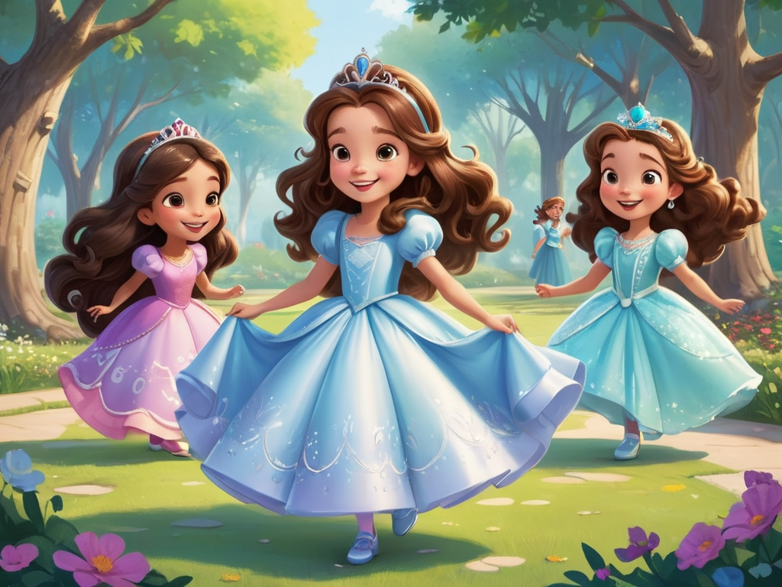

A young girl called Sophia Wearing a princess gown and a tiaraSmiling gentlyLong wavy brown hairKind and compassionate personalityFantasy illustration style As the day comes to an end, Sophia says goodbye to her friends and heads home. Before falling asleep, she smiles as she remembers the day’s adventure.

